Course Assignment in Platform Economics

The Effect of Musk’s Twitter Acquisition on Platform Interest:

A Difference-in-Difference Approach using Google Trends”

Elya Madambekova Uysal

April 17, 2025

**1. Introduction**

On April 14, 2022, Elon Musk publicly announced his intention to acquire Twitter, generating intense media attention and global discussion. This event provides a natural experiment to assess whether public interest in Twitter increased following the announcement. To investigate this, I collected search volume data from Google Trends for six major platforms: Twitter, Facebook, Instagram, TikTok, LinkedIn, and YouTube, from 2019 to 2024. Using a Difference-in-Differences (DiD) framework, the effect of the acquisition on public attention to Twitter was isolated, compared to other platforms.

**2. Data**

Search volume data were collected using the pytrends Python package, which allows for automated weekly data retrieval from Google Trends. Manual exports were initially tested but were found to be incomplete and inconsistent due to: 1) Export restrictions on date range granularity. 2) Platform-specific truncation. 3) Region-based sampling bias.

To address these issues, a VPN was used to ensure full-year access across all platforms and geographies. Data span January 2019 to December 2024, with global weekly interest values normalized between 0 and 100. To make comparisons across platforms possible, the data were standardized (z-scores) within each platform.

Treatment group: Twitter

Control group: Facebook, Instagram, TikTok, LinkedIn, YouTube

Event date: April 14, 2022

**3. Empirical Design**

We estimate a standard DiD model:

$$y_{\left\{it\right\}}= β_{0}+ β_{1}Post_{t}+ β_{2}Treat_{i}+ β_{3}\left(Post_{t}×Treat_{i}\right)+ γ_{t}+ δ_{i}+ ε_{\left\{it\right\}}$$

Where $:$

$y_{i}t$ Is the standardized weekly search interest for platform i at time t

$Treat_{i}$*=* 1 if the platform is Twitter,

$Post_{t}$*=* 1 for dates on or after April 14, 2022,

$Post_{t}×Treat_{i}$ Is the interaction term capturing the treatment effect

$γ_{t}+ δ_{i}$ Represent time and platform fixed effects,

$ε_{\left\{it\right\}}$ Standard errors are clustered at the platform level.

Also, an event study specification was estimated using week-level dummy variables relative to the event date to:Check the parallel trends assumption,Visualize dynamic treatment effects over ±12 weeks.

**4. Results**

The DiD regression results (table below) show that the interaction term Post × Treatment, which captures the differential effect of the announcement on Twitter versus other platforms, is negative and statistically insignificant: Coefficient = –0.2586, p-value = 0.479

This suggests that Twitter's search interest did not increase significantly relative to the control platforms after the event. The estimated effect is negative, though imprecise. Post (1.0731, p = 0.002): search volume increased on average across all platforms after April 14, 2022. Treatment (–0.4382, p = 0.025): Twitter had a lower average baseline interest compared to other platforms. Trend × Treatment (0.0055, p = 0.114): not statistically significant, suggesting no strong differential trend for Twitter.

| **Variable** | **Coefficient** | **Std. Error** | **z-Stat** | **p-Value** | **95% CI (Lower)** | **95% CI (Upper)** |
| --- | --- | --- | --- | --- | --- | --- |
| **Treatment** | –0.4382 | 0.196 | –2.23 | 0.025 | –0.823 | –0.054 |
| **Post** | 1.0731 | 0.353 | 3.04 | 0.002 | 0.381 | 1.766 |
| **Post × Treatment** | –0.2586 | 0.366 | –0.71 | 0.479 | –0.975 | 0.458 |
| **Time Trend** | –0.0033 | 0.003 | –0.97 | 0.331 | –0.010 | 0.003 |
| **Trend × Treatment** | 0.0055 | 0.003 | 1.58 | 0.114 | –0.001 | 0.012 |
| **Platform: TikTok** | –0.0104 | 0.058 | –0.18 | 0.858 | –0.124 | 0.103 |
| **Platform: Twitter** | –0.4382 | 0.196 | –2.23 | 0.025 | –0.823 | –0.054 |
| **Month 2** | –0.1457 | 0.085 | –1.71 | 0.088 | –0.313 | 0.021 |
| **Month 11** | –0.6111 | 0.282 | –2.17 | 0.030 | –1.163 | –0.059 |

*(Other months omitted)* Note: Standard errors are clustered at the platform level. R² = 0.165. N = 1780 observations.

EventStudy:

The event study plot (Figure 1) reveals: 1) Parallel trends before April 2022. 2) a **short-lived positive spike** in search interest immediately following the announcement, peaking at nearly **+2.5 standard deviations.** However, the effect is not statistically significant due to wide confidence intervals**.**  
The impact **dissipates within 3–5 weeks,** suggesting a **temporary surge in attention** likely driven by news coverage and social media buzz, rather than sustained engagement.

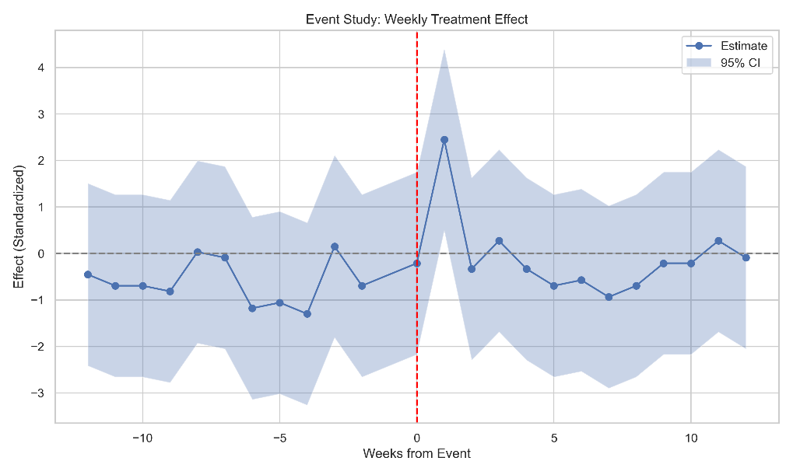

Barplot:

The bar chart (Figure 2) displays average search interest before and after April 14, 2022:

TikTok and Instagram show continued growth, LinkedIn and Facebook remain stable,

Twitter shows a small average increase, consistent with short-lived attention gains.

**5. Discussion**

We applied several improvements to enhance the validity of the Difference-in-Differences (DiD) estimation. These include:

Event Study Specification: Instead of relying solely on a binary Post × Treatment variable, a week-by-week interaction model (±12 weeks) was implemented. This allowed us to assess the dynamics of the treatment effect and test the parallel trends assumption.

Time Trend Adjustment: A continuous time trend variable and its interaction with the treatment group were included. This captures differences in baseline growth rates between Twitter and control platforms before the treatment.

Fixed Effects: Added month and platform fixed effects to control seasonal variation and platform-specific characteristics.

Standardization: Normalized search volume within each platform (z-scores), allowing comparability across platforms despite the relative nature of Google Trends data.

Across all three methods, mixed but generally non-significant results were observed. The simple before/after barplot suggests a rise in interest, while the DiD regression estimates a small negative effect. The event study shows an initial spike followed by a decline, reinforcing the view that any effect was short-lived. These differences highlight the sensitivity of results to modeling choices and suggest the need for further robustness checks

**7. Limitations**

Model Sensitivity and Conflicting Signs: The standard DiD interaction (Post × Treatment) assumes a constant effect post-event. However, our event study indicates dynamic and possibly non-linear responses, suggesting that a single coefficient may oversimplify treatment effects.

No Placebo Tests: Falsification tests using placebo treatment dates were not run. A placebo DiD test one year before the actual event (e.g., April 2021) could help validate causal interpretation.

No Additional Control Variables: The model does not account for exogenous shocks (e.g., platform-specific scandals, outages, or concurrent events) that may bias estimates.

No Alternative Specifications: Sensitivity to different treatment dates was not tested, nor were the definitions of the outcome variable or sub-sample splits (e.g., excluding TikTok, which shows strong growth).

Limitations of Google Trends: The data represent normalized relative interest (0–100) and do not reflect actual user counts. Sampling variability and weekly smoothing by Google may also introduce noise. While a VPN was used to access consistent international data, small sampling differences may remain.

**References**

Callaway, B., & Sant'Anna, P. H. C. (2021). Difference-in-Differences with multiple periods.

Abadie, A. (2005). Semiparametric DiD estimation. Google Trends Documentation: trends.google.com. Reuters (2022). "Elon Musk offers to buy Twitter," Jonathan Roth, April 2023: “What’s trending in Difference-in-Differences” <https://www.jonathandroth.com/assets/files/DiD_Review_Paper.pdf>

During the research analysis, Generative AI (ChatGPT) was used to improve and learn some parts of the Python code, and Grammarly.com was used to improve the readability of the research paper.